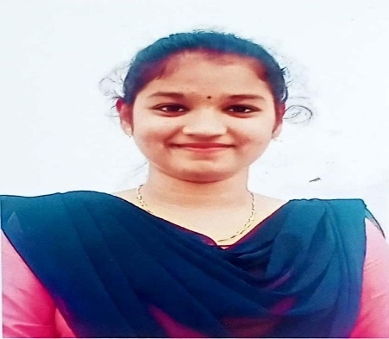

HEY I’M, BUDATA DAIVA KRUPA

I’M UNDERGRADUATE STUDENT AT

VISAKHA INSTITUTE OF

ENGNEERING AND TECHNOLOGY

VISAKHAPATNAM

FRONTEND DEVELOPER PYTHON

PROGRAMMER PENTESTER

@ BUDATA DAIVA KRUPA